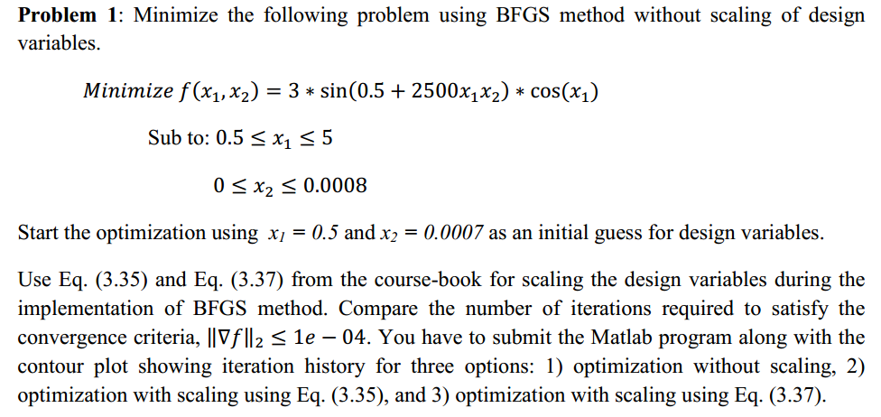

1. **Optimization without scaling**

a)while finding alpha, if didn’t not apply an constraint (outside bound optimization)



b) with limit to alpha



Change alpha when reaching bounds is almost useless. By changing alpha to a value that let x stay in the bound, the next iteration will still moving towards almost the same direction. After getting almost the same results from a), I tried to change direction S. But by changing S, the search direction starts to oscillate.

while x(2)<0 || x(2)>0.0008||x(1)<0.5||x(1)>5

fprintf('out of bound iteration\n')

x=xold

HR=[sqrt(3)/2 -1/2;1/2 sqrt(3)/2];%rotate search direction

%HR=[0 -1;1 0];

x=x+A*HR*ST

ST=HR*ST;

if nr==11

A=0.6*A;

% A=0.9*A;

nr=0;

end

nr=nr+1;

end

update H every three iteration:



Still can’t find the optimization solution.

1. **optimization with scaling using Eq 3.35**

Desgin :let z1=5000x1x2 z2=x1

D=[ 5000*x2 0 ]

[ 0 x1/x2 ]

Result n = 5

history = 1.7500 0.5000

1.2781 3.0998

1.6223 3.3342

2.1408 3.1411

2.1416 3.1416

5000*x1*x2=2.1416

**X1=3.1416, x2=0.000136338 fmin=-3 feasible optimization solution**



Transform F(X) to f(x) using X= $D^{-1}*\overline{X}$



1. **optimization with scaling using Eq 3.37**

Desgin :let z1=5000x1x2 z2=x1

Programs

%BFGS 1 MIDTERM

f = @(x1,x2)3*(sin(0.5+2500*x1*x2))*cos(x1);

ezcontour(f,[0,5],[0,0.001])%axis([0 5 -0.001 0.005]);

hold on

%%%%%%%%%%%%%%%%%%%%%%%%%%%%%%%

x=[0.5;0.0007]; %starting point

tol=0.0001;

dx=0.01;

a=1.61803;

b=0.0005;

f = @(x) 3*(sin(0.5+2500*x(1)*x(2)))*cos(x(1));

n=1;%starting iteration

SIZE=size(x);

H=eye(SIZE(1));%H starting as I matrix

xold=x; %xq-1

ni=0;

while(n<200)

nr=0

x1history(n)=x(1); %save x data to xhistory

x2history(n)=x(2);

S=@(x) gradientlin(f,dx,xold);

ST=-H*S(x)' %Search direction

A=0; %initial A

minf=@(A) f(x+(A*ST));

GOLD=GoldSection_1Var(minf,tol,A,a,b,10)

A=GOLD(1)

xold=x

xold2=x;

x=x+A*ST%update x

ftemp=feval(f,x)

while x(2)<0 || x(2)>0.0008||x(1)<0.5||x(1)>5

fprintf('out of bound iteration\n')

x=xold

HR=[sqrt(3)/2 -1/2;1/2 sqrt(3)/2];%rotate search direction

%HR=[0 -1;1 0];

x=x+A*HR*ST

ST=HR*ST;

if nr==11

A=0.9*A;

% A=0.9*A;

nr=0;

end

nr=nr+1;

end

p=x-xold;%p is the same

y=gradientlin(f,dx,x)-gradientlin(f,dx,xold);% 3.12b y is y'

sigma=p'*y';%3.22a

t=y*H*y';%3.22b

coe1=(sigma+t)/(sigma.^2);

coe2=1/sigma;

UD=coe1*p*p'-coe2*(H*y'*p'+p*(H*y')');%3.20

H

if ni==3

H=H+UD%3.19 update H

ni=0;

end

%E=gradientlin(f,dx,x)-gradientlin(f,dx,xold)

E=gradientlin(f,dx,x)

if norm(E)<=1.0e-004

condition=1;

break

end

if abs((feval(f,x)-feval(f,xold)))<=0.0001

condition=2;

%break

end

n=n+1;

ni=ni+1;

end

n

condition

history=[x1history' x2history']

plot(x1history,x2history,'LineWidth',1)

axis([0 5 0 0.001]);

%BFGS 2 method

f =@(x1,x2)3*(sin(0.5+0.5*x1))*cos(x2);

ezcontour(f,[0,20],[0,5])

hold on

%%%%%%%%%%%%%%%%%%%%%%%%%%%%%%%%%%%%%%%

x=[1.75;0.5]; %starting point

tol=0.0001;

dx=0.01;

a=1.61803;

b=0.0005;

f = @(x) 3*(sin(0.5+0.5*x(1)))*cos(x(2));

n=1;%starting iteration

SIZE=size(x);

H=eye(SIZE(1));%H starting as I matrix

xold=x; %xq-1

while(1)

x1history(n)=x(1); %save x data to xhistory

x2history(n)=x(2);

x3history(n)=x(2);

x4history(n)=x(1)/(5000*x(2))

S=@(x) gradientlin(f,dx,xold);

ST=-H*S(x)' %Search direction

A=0; %initial A

minf=@(A) f(x+(A*ST));

GOLD=GoldSection_1Var(minf,tol,A,a,b,10)

A=GOLD(1)

xold=x;

x=x+A*ST%update x

p=x-xold;%p is the same

y=gradientlin(f,dx,x)-gradientlin(f,dx,xold);% 3.12b y is y'

sigma=p'*y';%3.22a

t=y*H*y';%3.22b

coe1=(sigma+t)/(sigma.^2);

coe2=1/sigma;

UD=coe1*p*p'-coe2*(H*y'*p'+p*(H*y')');%3.20

H=H+UD;%3.19 update H

E=gradientlin(f,dx,x)-gradientlin(f,dx,xold)

xold=x;

if norm(E)<=tol

break

end

n=n+1;

end

n

history=[x1history' x2history']

plot(x1history,x2history,'LineWidth',2)

axis([0 20 0 5]);

%%%%%%%%%%%%%%%%%%%%%%

%transform

plot(x3history,x4history)

f = @(x1,x2)3*(sin(0.5+2500*x1*x2))*cos(x1);

ezcontour(f,[0,5],[-0.0001,0.001])

axis([0 5 -0.0001 0.001]);

hold on